-Improve the detection of particle fractures in micro-scale video of particle-reinforced composites
-Use an existing algorithm/architecture to detect particle fractures, without counting the same fracture more than once
-Pursuing a ML approach to fracture detection
-The primary materials for which we have microscope video are coal-polymer composites with 40 and 60% by-weight P8 and PRB coal
-Previous attempts to mask included using OpenCV, Meta SAM and SAM 2, and CellPose v3

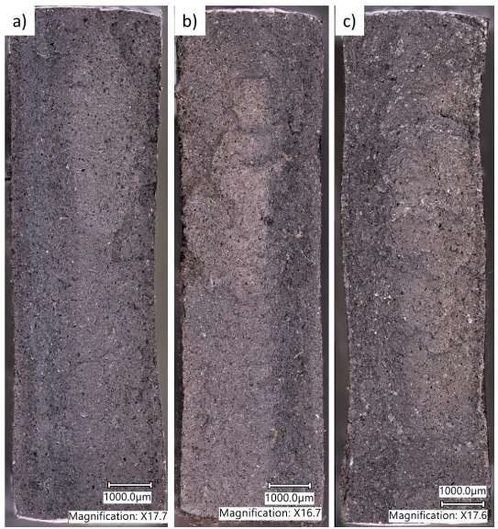
Figure 1: Microscope images of 40% (a), 50% (b), and 60% (c) P8 formulations
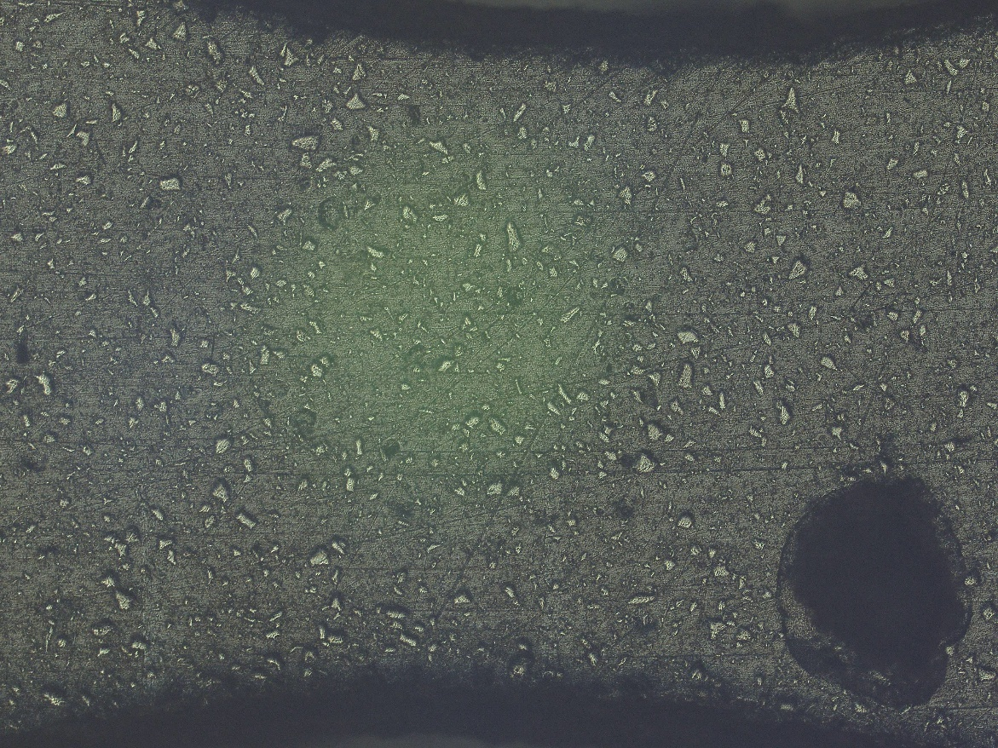
Figure 2: H40PRB
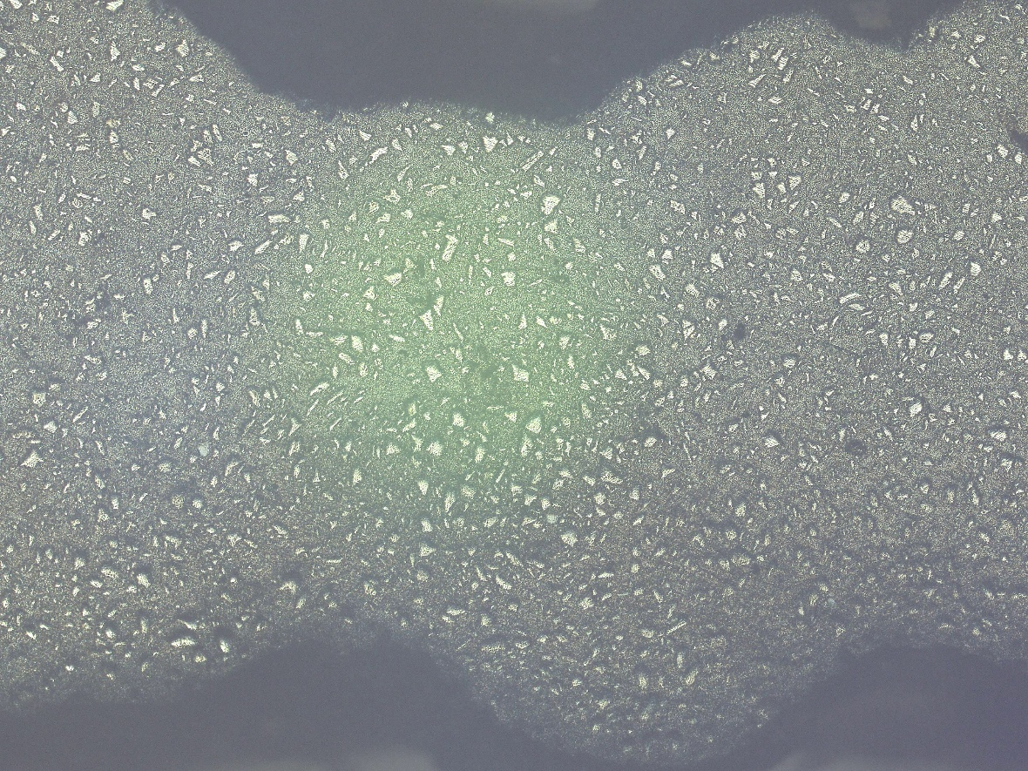
Figure 3: H60PRB
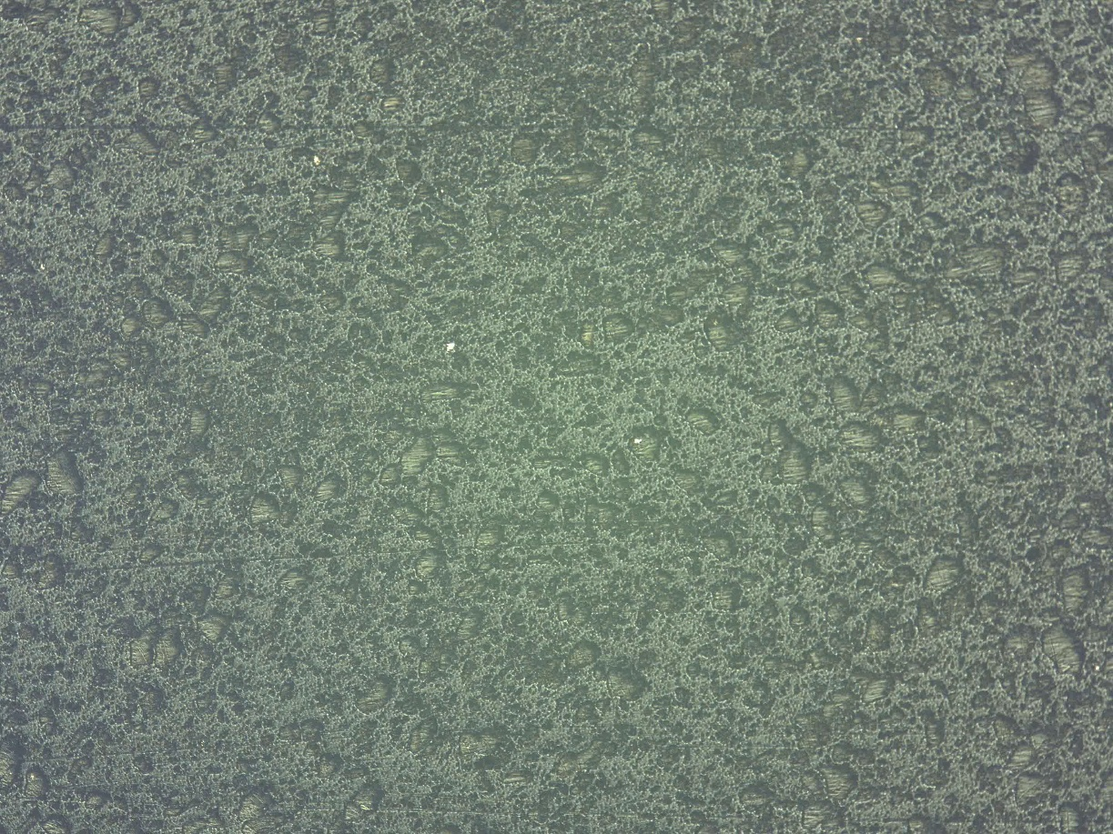
Figure 4: H40P8
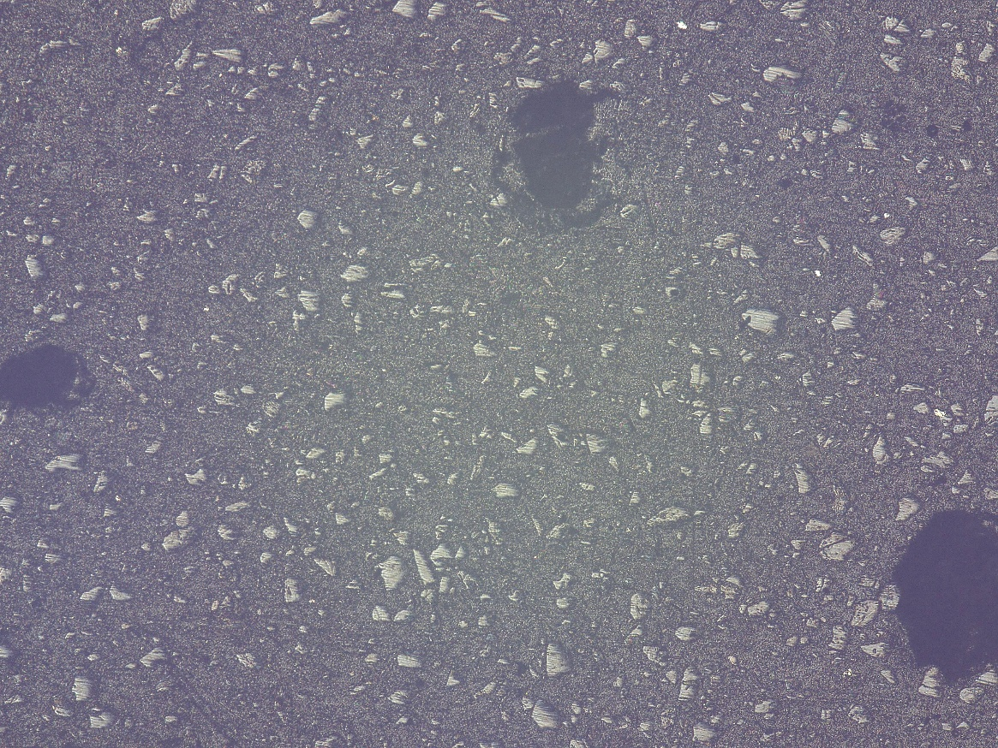
Figure 5: H60P8
Pre-fracture | Post-fracture
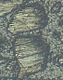 | 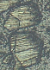
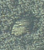 | 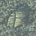
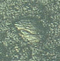 | 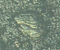
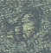 | 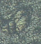
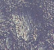 | 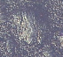
Table 1: Pre- and post-fracture images from H40P8 and H60P8
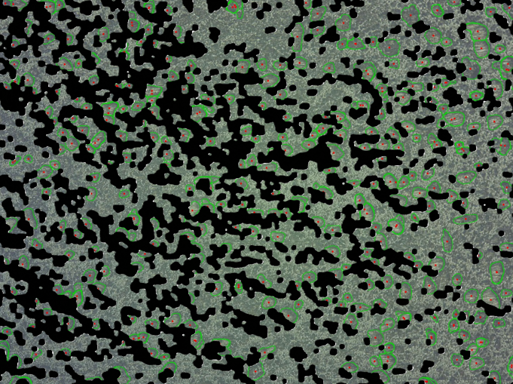Figure 6: OpenCV best masking attempt (black = matrix)
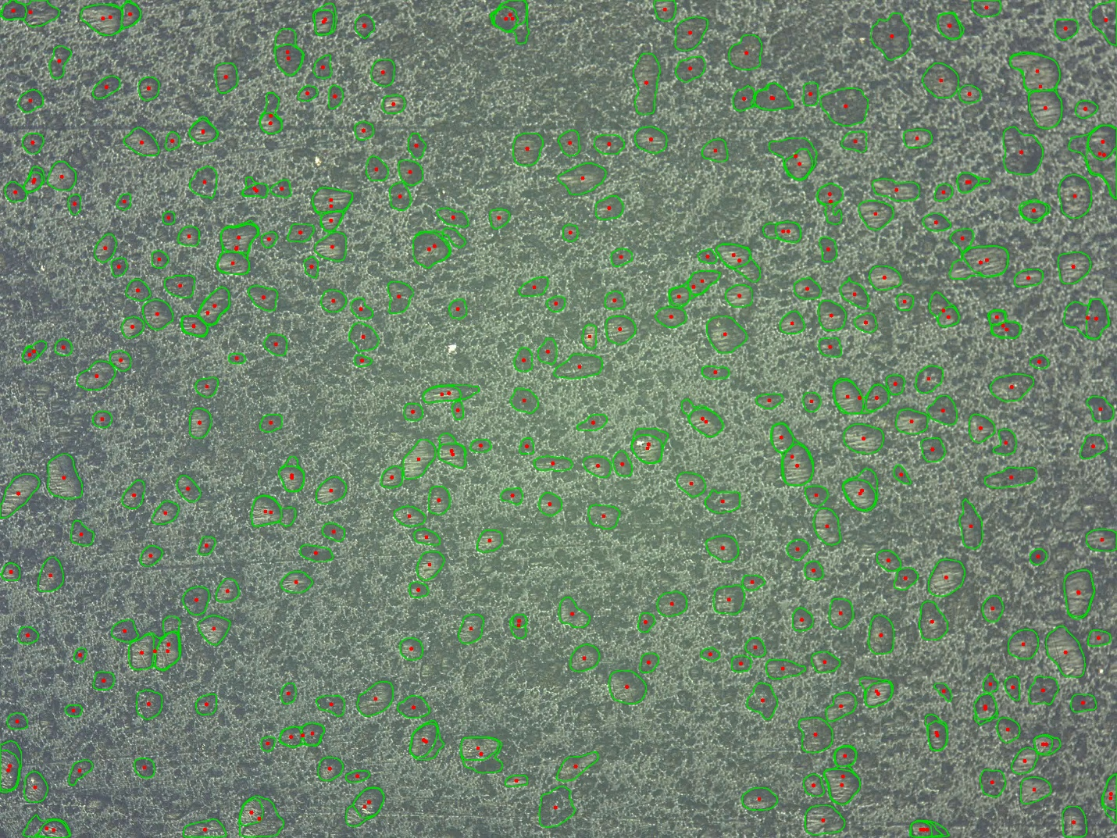
Figure 7: SAM best masking attempt
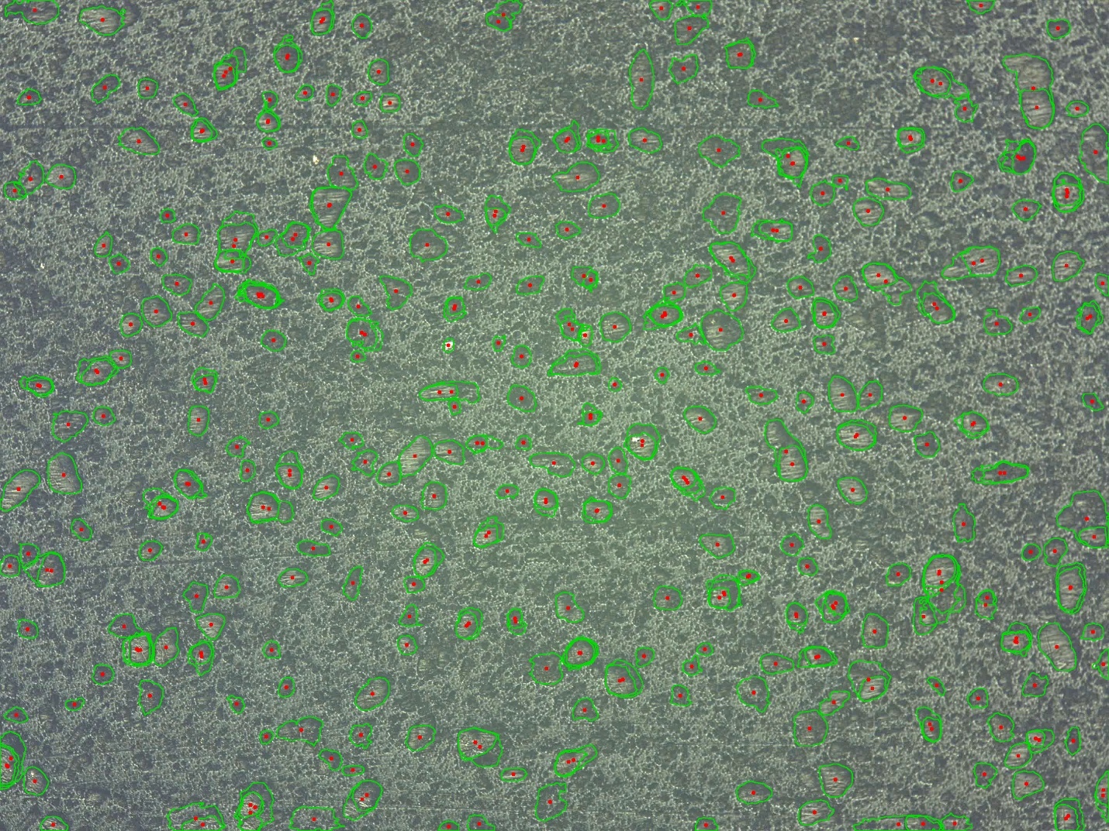
Figure 8: SAM 2 best masking result

